Criminal and Civil Law

Criminal law involves an offence that is seen as a threat to the whole community.
Examples of criminal acts include:
__________________________________________________________________________________
__________________________________________________________________________________
The Government takes responsibility for taking people accused of crimes to court and have them answer for what they have done.

The crimes can be categorised into four groups:

1.
2.
3.
4.


Bail delay for boy on murder charge
Amanda Banks Legal Affairs Editor
Wed, 17 February 2016 7:25PM
An 11-year-old boy accused of murder had been charged with armed robbery and granted bail by police a week before he was allegedly involved in the fatal bashing, it was revealed in a Perth court today.
Emotional scenes erupted outside Perth Children’s Court after a bail application for the boy was adjourned, with family members of the man who died voicing a mix of anger and grief.
“We believe that if this child should be found guilty, he should be convicted to the full extent of the law for his actions as an adult.
“And that the responsibility for his actions should also fall back on to his legal guardians.”
Do you agree with the above statements? Explain your point of view:
__________________________________________________________________________________
__________________________________________________________________________________
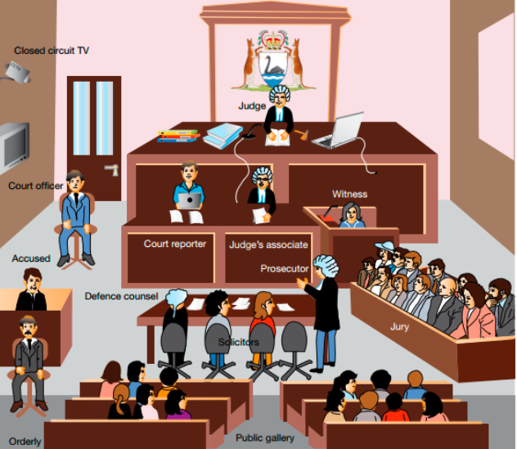
Criminal cases are held in a court. Fill-in the blanks from information on the PowerPoint:

Civil law involves disputes between individuals rather than the community as a whole.
Examples of civil law disputes include:
__________________________________________________________________________________
__________________________________________________________________________________

There are three main types of civil law:
1.
2.
3.

Torts are wrongful acts that result in injury to another.
Examples of torts include:
__________________________________________________________________________________
__________________________________________________________________________________

Torts can be classified in four ways:

1.
2.
3.
4.

In the famous case of Donoghue v Stevenson, what was Stevenson found to have been negligent of?

__________________________________________________________________________________
__________________________________________________________________________________

Review:
- What does ‘deterrent’ mean?

- changing behaviour
- punishment
- not being allowed to do something
- discouragement from doing something

2. What is the role of the judge?
- to prosecute the accused
- to interpret and apply the law
- to direct the police investigation
- to make new laws

Examine the diagram below which shows the hierarchy of courts in Australia.
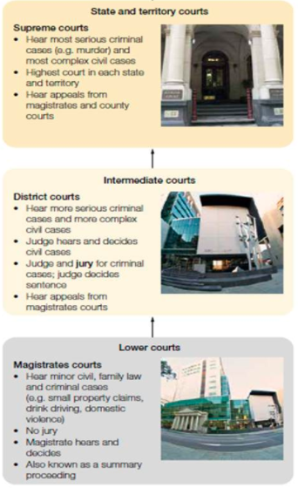
3. Which court hears minor criminal cases?
- Federal Court
- District Court
- Magistrates Court
- Supreme Court

4. What is the role of a jury in a criminal case?
- to prosecute the plaintiff
- to interpret and apply the law
- to hand down the sentence
- to decide if the accused is innocent or guilty

5. Who are the two parties in a civil case?
- prosecution and defence
- witness and accused
- judge and jury
- plaintiff and defendant

Bibliography:
Addison, P., Butler, J., Byrne, P., Dresden, G., Kleeman, G., Lane, R., . . . Van Tol, D. (2017). Humanitities & Social Sciences 8: Western Australia. Melbourne: Pearson.
Conti, L., Easton, M., Saldais, M., Smith, & Dumovic, V. (2017). In Oxford Big Ideas: Humanities and social sciences 8 Western Australian curriculum. Melbourne: Oxford University Press.

